Kaya buildings

William F. Lamb

2 12 2020

output: word_document: knit: (function(inputFile, encoding) { rmarkdown::render(inputFile, encoding = encoding, output_dir = “../../Results”) }) —

## Residential

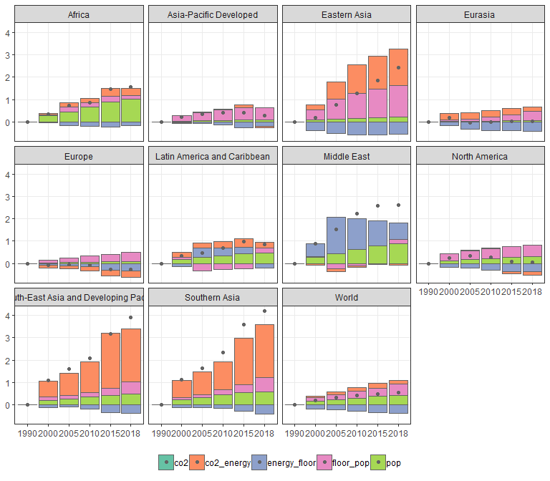

## Non-residential

